**Final report (Option 1)**

Course name: Multimedia Processing Technique (DD026_1594)  
Project number: Option 1-8  
Project name: Survey the paper: A Convolutional Neural Network Cascade for Face Detection  
Paper link:  
https://openaccess.thecvf.com/content_cvpr_2015/html/Li_A_Convolutional_Neural_2015_CVPR_paper.html   
Student name: Noh Sujin (노수진), 201912056  
Github of project: https://github.com/ssuzz1n/FinalReport_MultimediaProcessingTechnique.git

**Report:**

**1. Purpose of the study**  
In real-world face detection, large visual variations, such as those due to pose, expression, and lighting, demand an advanced discriminative model to accurately differentiate faces from the backgrounds.   
The difficulties in face detection mainly come from two aspects:   
1) the large visual variations of human faces in the cluttered backgrounds  
2) the large search space of possible face positions and face sizes  
Originally the boosted cascade with simple features was the most popular and effective design for practical face detection. However, due to the simple nature of the Haar feature, it is relatively weak in the uncontrolled environment where faces are in varied poses, expressions under unexpected lighting. Therefore, this paper proposes a cascade architecture built on convolutional neural networks (CNNs) with very powerful discriminative capability, while maintaining high performance to address problems.

**2. Related Work**  
**2.1 Neural network base face detection**  
- Early in 1994: Vaillant proposed to train a convolutional neural network to detect the presence or absence of a face in an image window and scan the whole image with the network at all possible locations.   
- In 1996: Rowley presented a retinally connected neural network for upright frontal face detection.   
- In 2002: Garcia developed a neural network to detect semi-frontal human faces in complex images  
- In 2005: Osadchy trained a convolutional network for simultaneous face detection and pose estimation.  
Given recent break-through results of CNNs for image classification and object detection, it is worth to revisit the neural network based face detection.  
One of the recent CNN based detection method is the R-CNN by Girshick which has achieved the state-of-the-art result on VOC 2012. R-CNN follows the “recognition using regions” paradigm. It generates category-independent region proposals and extracts CNN features from the regions. Then it applies class-specific classifiers to recognize the object category of the proposals. However, the general object proposal methods may not be effective for faces due to small-sized faces and complex appearance variations because un-controlled face detection.  
**2.2 Face detection in uncontrolled environments**  
Previous uncontrolled face detection systems are mostly based on hand-crafted features.   
<A number of variants for real-time face detection>  
- The boosted cascade with simple features framework: Chen propose to use the shape indexed features to jointly conduct face detection and face alignment. We are similar to this idea. However, Considering the success of CNNs in a number of visual tasks including the face alignment, our framework is more general in that we can adopt a CNN-based face alignment method to achieve joint face alignment and detection.  
- The multi-resolution idea in general object detection: we are similar to this technique, But our method utilizes CNNs as the classifiers and combines the multi-resolution and calibration ideas for face detection.  
- The part-based model: Zhu propose the tree structured model for face detection which can simultaneously achieve the pose estimation and facial landmarks localization. Yan presents a structural model for face detection. Mathias show that a carefully trained deformable part-based model achieves state-of-the-art detection accuracy. Different from these model-based methods, Shen propose to detect faces by image retrieval. And Li further improves it to a boosted exemplar-based face detector with state-of-the-art performance.  
Compared with these face detection systems, this paper works learns the classifier directly from the image instead of relying on hand-crafted features. Hence we benefit from the powerful features learned by the CNN to better differentiate faces from highly cluttered backgrounds.

**3. Course of study**This paper introduces a CNN-based calibration stage after each of the detection stages in the cascade.

<The overall test pipeline of our face detector>

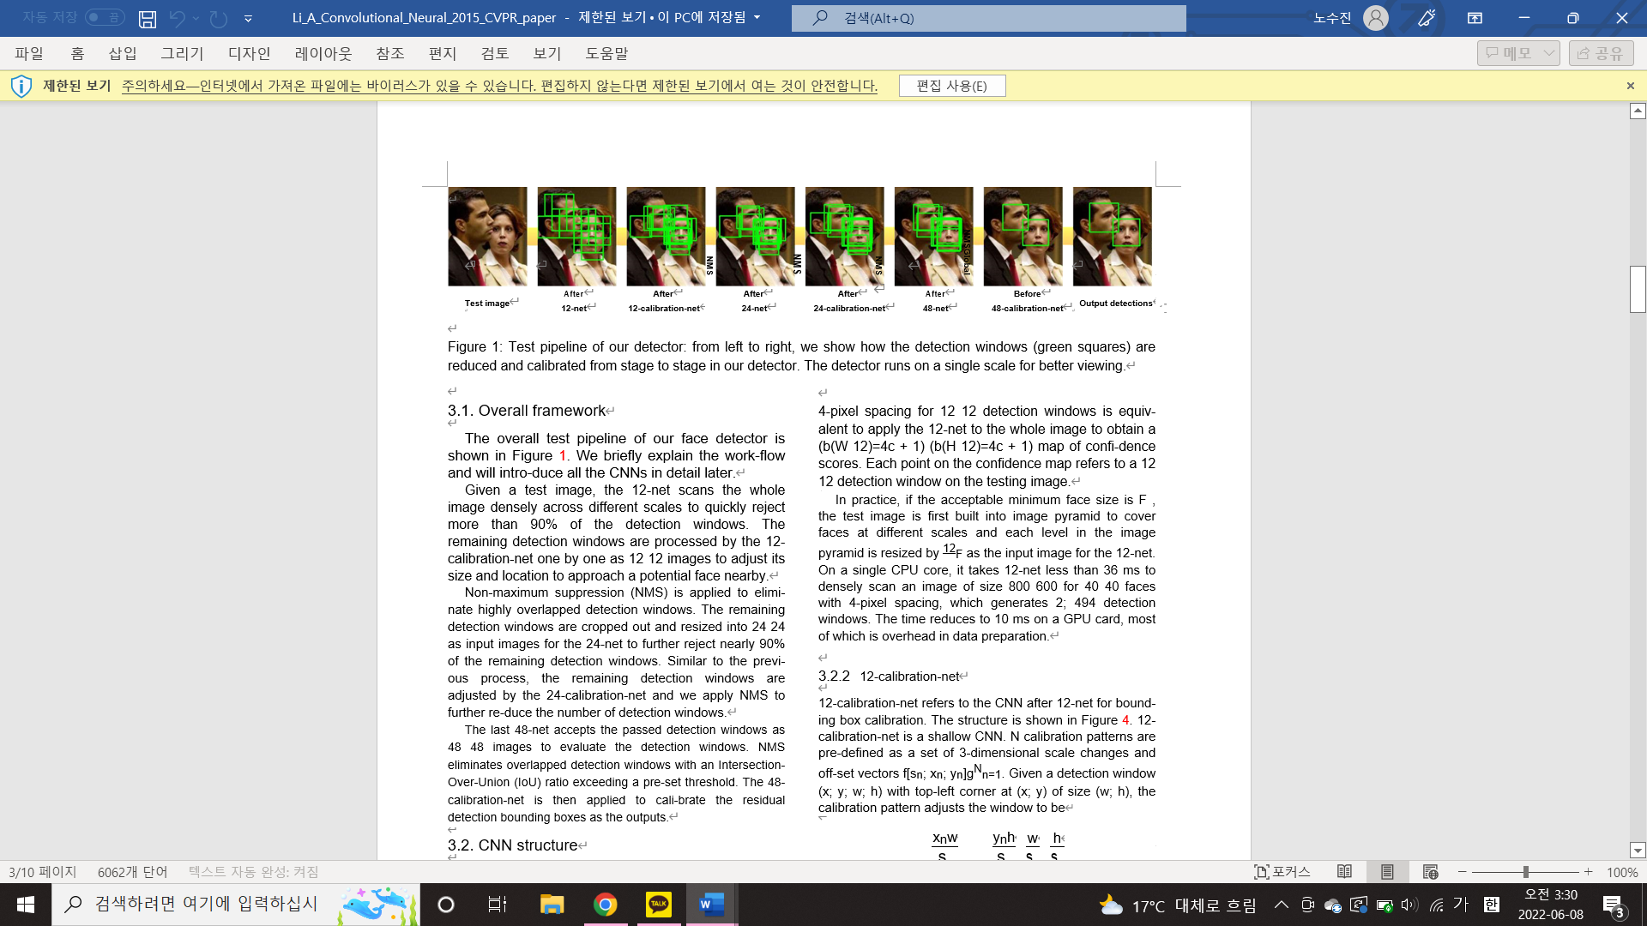

There are 6 CNNs in the cascade including 3 CNNs for face vs. non-face binary classification and 3 CNNs for bounding box calibration, which is formulated as multi-class classification of discretized displacement pattern.

**3.1 CNN structure**  
**3.1.1 12-net**  
12-net refers to the first CNN in the test pipeline.

<The structure of this CNN>  
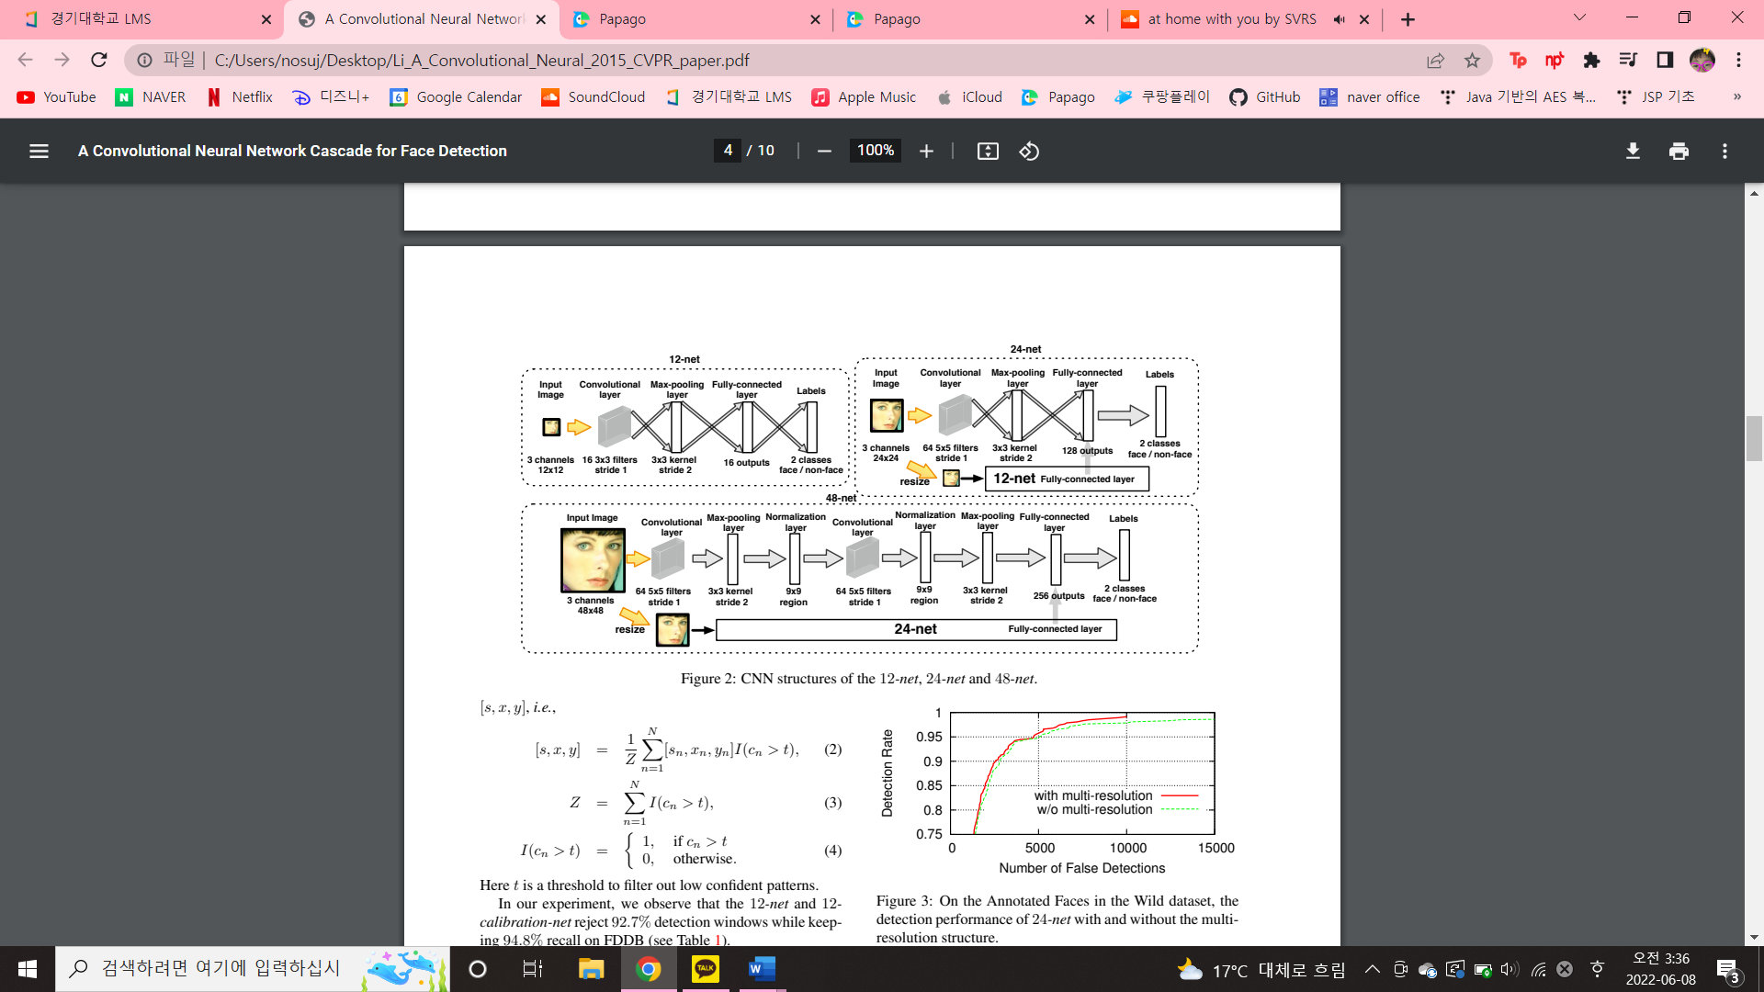

12-net is a very shallow binary classification CNN to quickly scan the testing image. Densely scanning an image of size W x H with 4-pixel spacing for 12 x 12 detection windows is equivalent to apply the 12-net to the whole image to obtain a map of confidence scores. Each point on the confidence map refers to a 12 x 12 detection window on the testing image. The time reduces to 10ms on a GPU card, most of which is overhead in data preparation. **3.1.2 12-calibration-net**  
12-calibration-net is a shallow CNN after 12-net for bounding box calibration.

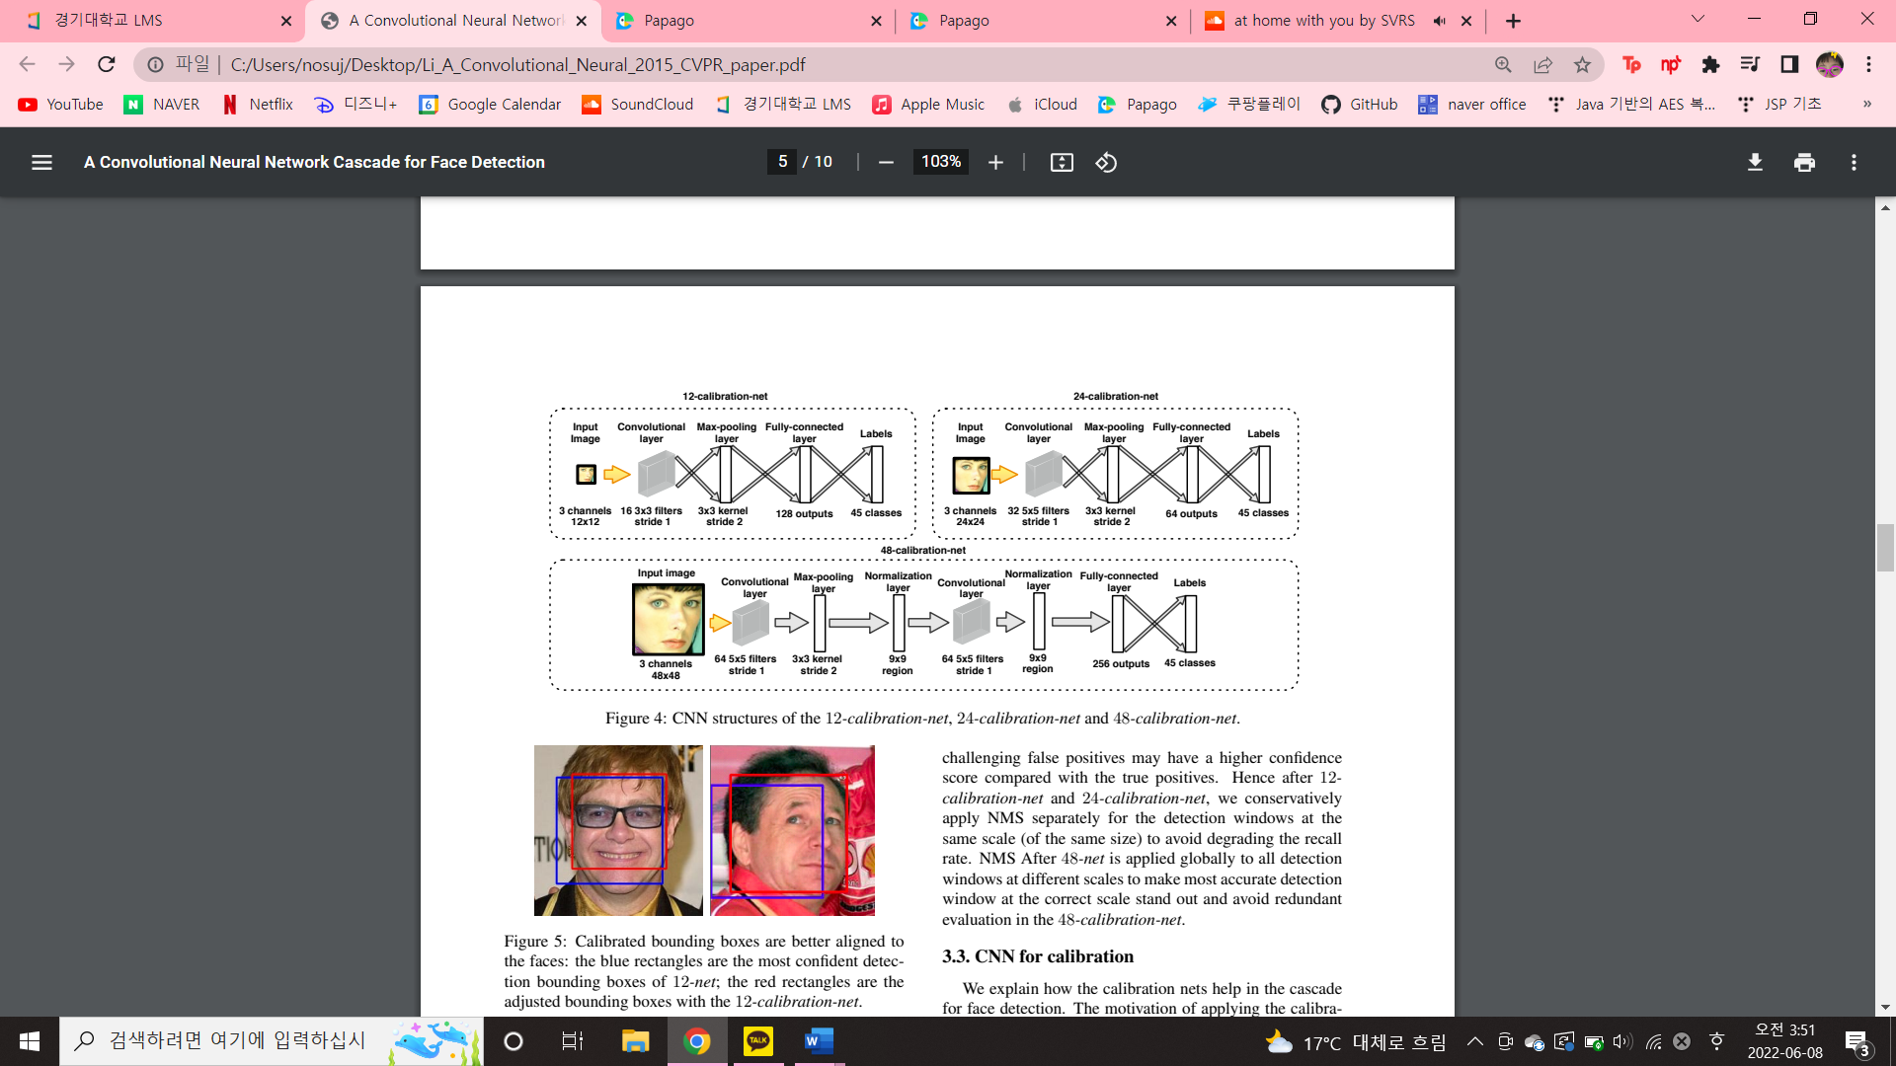

N calibration patterns are pre-defined as a set of 3-dimensional scale changes and off-set vectors .   
Given a detection window (x, y, w, h) with top-left corner at (x, y) of size (w, h), the calibration pattern adjusts the window to be  
  
this work have N = 45 patterns, formed by all combinations of   
Sn ∈ {0.83, 0.91, 1.0, 1.10, 1.21}   
Xn ∈ {−0.17, 0, 0.17}   
Yn ∈ {−0.17, 0, 0.17}.  
Given a detection window, the region is cropped out and resized to 12×12 as the input image for the 12-calibrationnet. The calibration net outputs a vector of confidence scores [c1 , c2, · · · , cN ].  
Since the calibration patterns are not orthogonal to each other, we take the average results of the patterns of high confidence score as the adjustment  
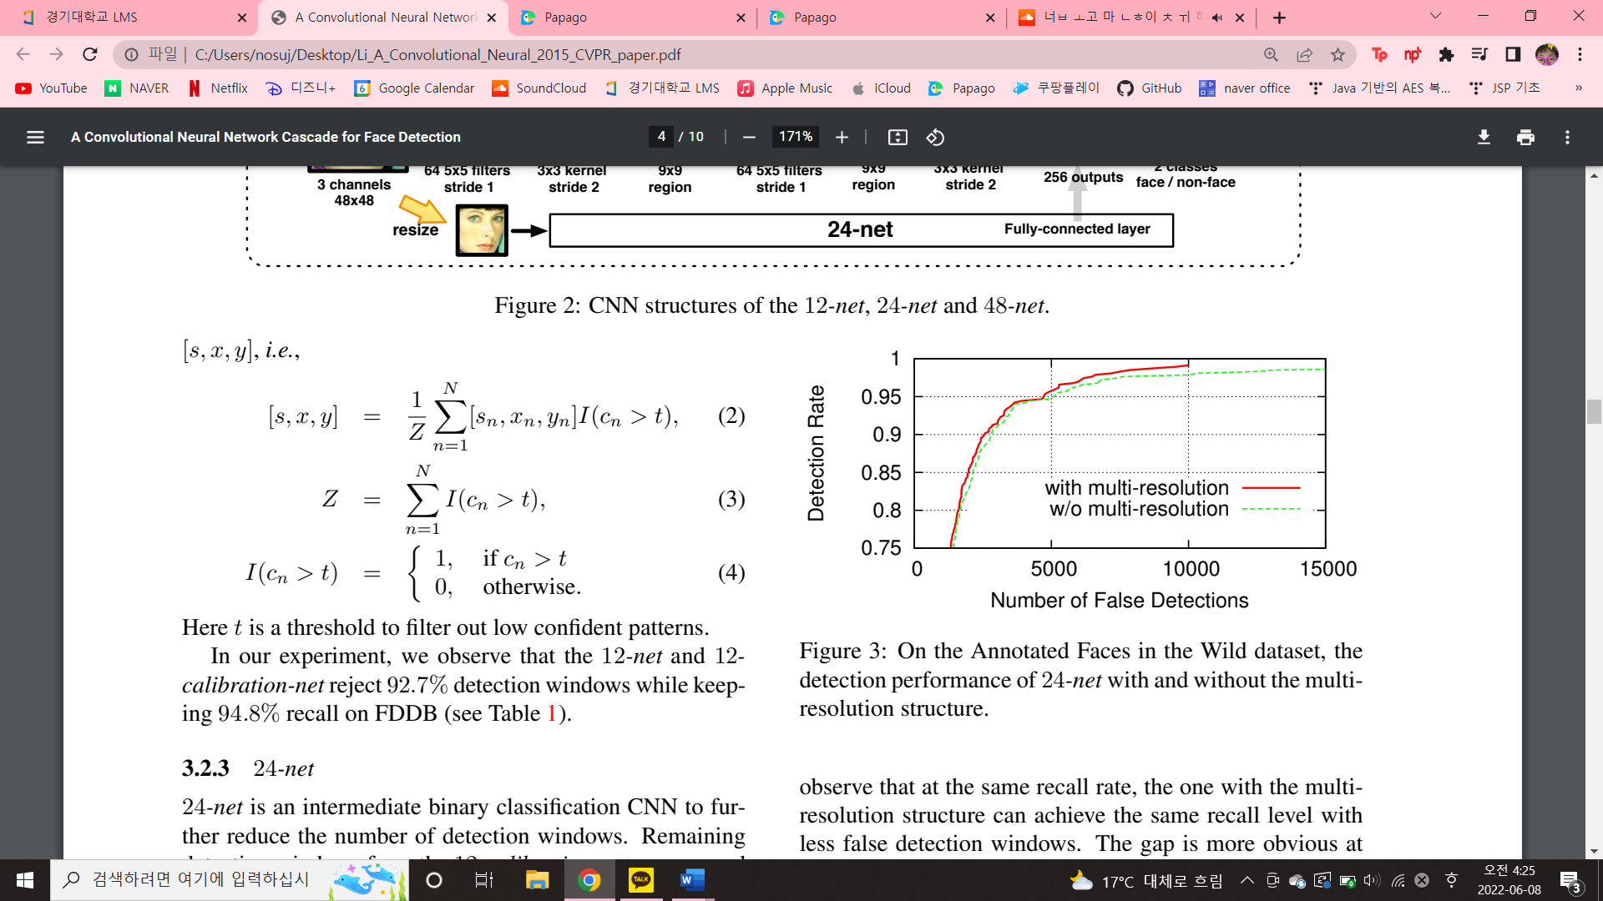  
Here t is a threshold to filter out low confident patterns.  
In our experiment, we observe that the 12-net and 12- calibration-net reject 92.7% detection windows while keeping 94.8% recall on FDDB



**3.1.3 24-net**

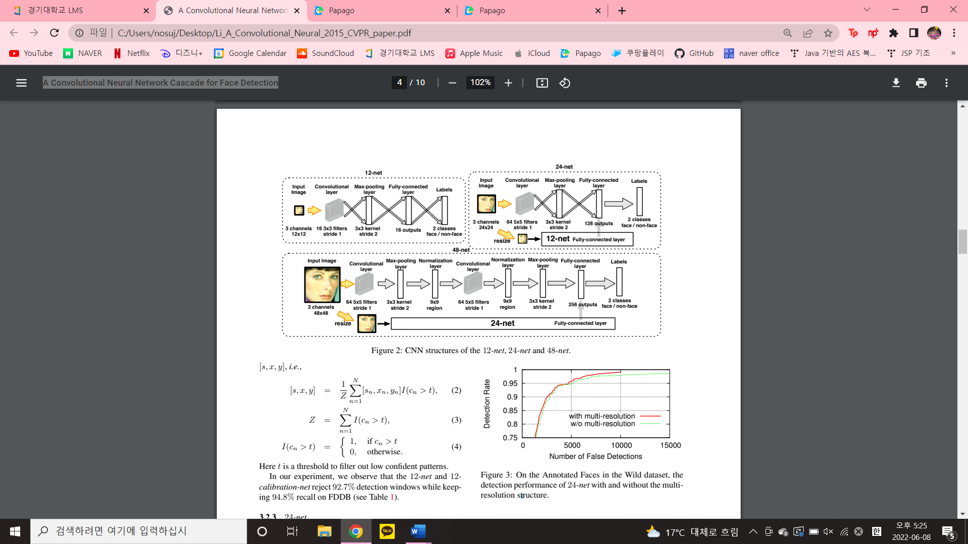

24-net is an intermediate binary classification CNN to further reduce the number of detection windows. Remaining detection windows from the 12-calibration-net are cropped out and resized into 24 x 24 images and evaluated by the 24-net.  
A similar shallow structure is chosen for time efficiency. Besides, we adopt a multi-resolution structure in the 24-net. In additional to the 24 x 24 input, we also feed the input in 12 x 12 resolution to a sub-structure same as the 12-net in 24-net. The fully-connected layer from the 12-net sub-structure is concatenated to the 128-output fully-connected layer for classification. With this multi-resolution structure, the 24-net is supplemented by the information at 12 x 12 resolution which helps detect the small faces. The overall CNN becomes more discriminative and the overhead from the 12-net sub-structure is only a fraction of the overall computation.

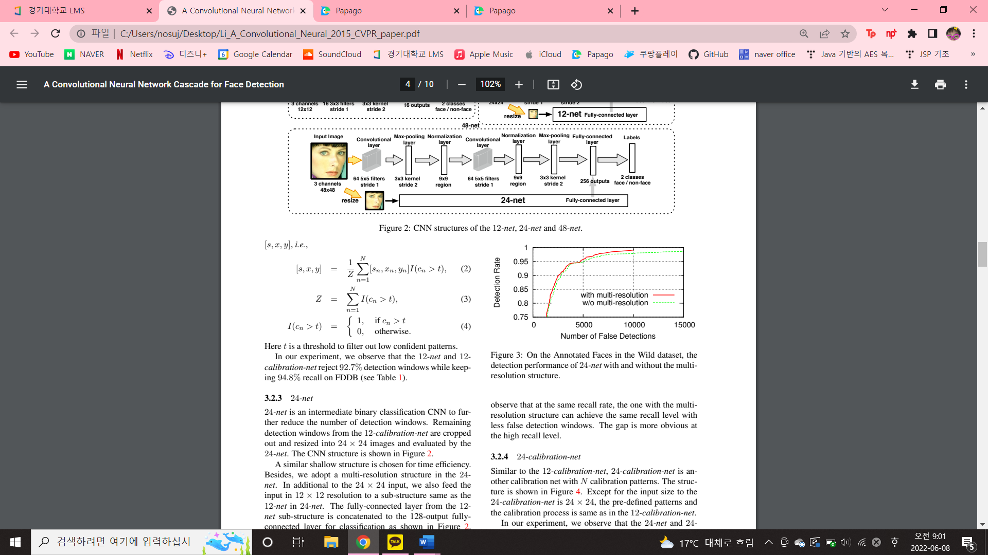

We can observe that at the same recall rate, the one with the multi-resolution structure can achieve the same recall level with less false detection windows. The gap is more obvious at the high recall level.  
**3.1.4 24-calibration-net**  
Similar to the 12-calibration-net, 24-calibration-net is an-other calibration net with N calibration patterns.

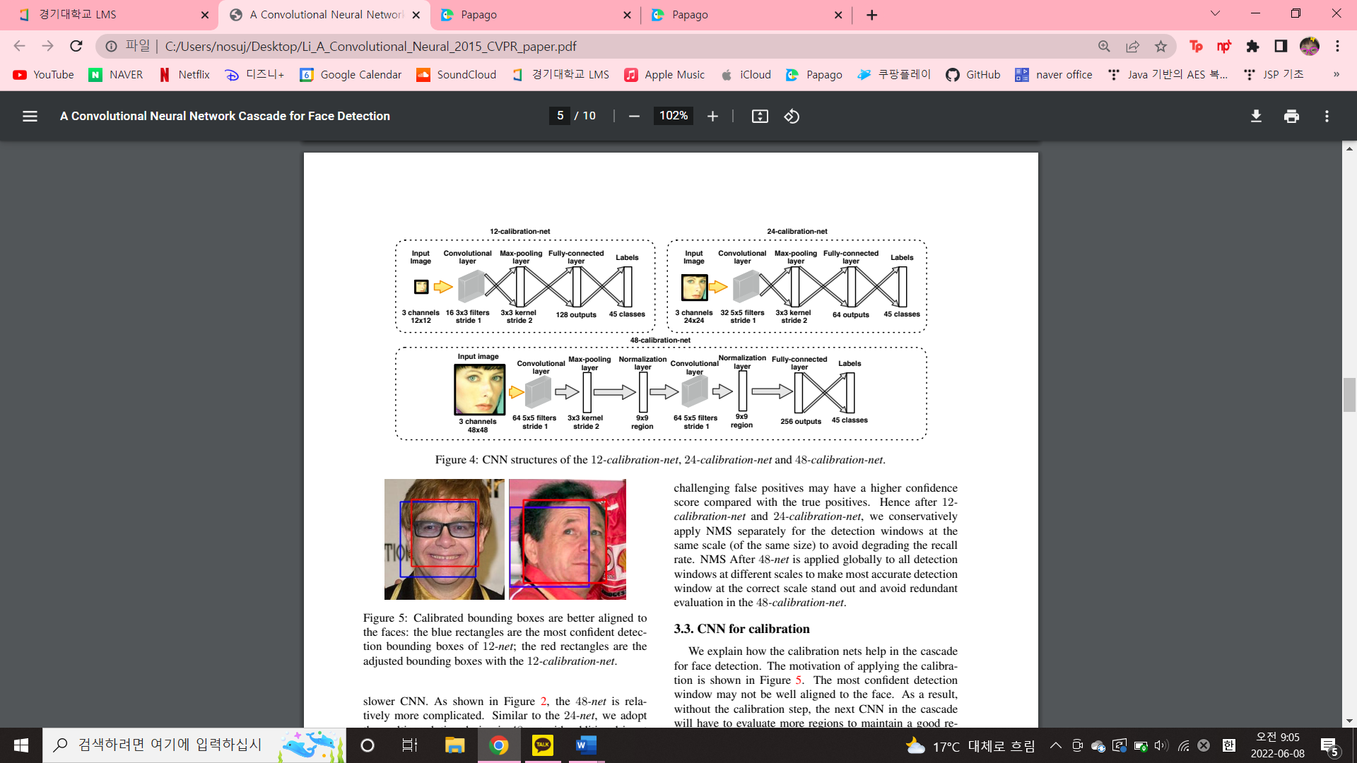

Except for the input size to the 24-calibration-net is 24 x 24, the predefined patterns and the calibration process is same as in the 12-calibration-net.  
In our experiment, we can observe that the 24-net and 24-calibration-net can further reject 86.2% detection windows retained after 24-calibration-net while keeping 89.0% re-call on FDDB.



**3.1.5 48-net**  
48-net is the last binary classification CNN and relatively more complicated. Similar to the 24-net, we adopt the multi-resolution design in 48-net with additional input copy in 24 x 24 and a substructure the same as the 24-net.  
**3.1.6 48-calibration-net**48-calibration-net is the last stage in the cascade.



The same N = 45 calibration patterns are pre-defined for the 48-calibration-net. We use only one pooling layer in this CNN to have more accurate calibration.  
**3.1.7 Non-Maximum Suppression (NMS)**  
This paper adopts an efficient implementation of the NMS in this work.  
In the 12-net and 24-net, the shallow CNNs may not be discriminative enough to address challenging false positives. After the 12-calibration-net and 24-calibration-net, challenging false positives may have a higher confidence score compared with the true positives. Hence after 12-calibration-net and 24-calibration-net, we conservatively apply NMS separately for the detection windows at the same scale (of the same size) to avoid degrading the recall rate.   
NMS After 48-net is applied globally to all detection windows at different scales to make most accurate detection window at the correct scale stand out and avoid redundant evaluation in the 48-calibration-net.

**3.2 CNN for calibration**The motivation of applying the calibration is



As shown above figure, the most confident detection window may not be well aligned to the face. As a result, without the calibration step, the next CNN in the cascade will have to evaluate more regions to maintain a good re-call. The overall detection runtime increases significantly. This problem generally exists in object detection. We explicitly address this problem with CNNs in this work. In-stead of training a CNN for bounding boxes regression as in R-CNN, we train a multi-class classification CNN for calibration. We observe that a multi-class calibration CNN can be easily trained from limited amount of training data while a regression CNN for calibration requires more training data. We believe that the discretization decreases the difficulty of the calibration problem so that we can achieve good calibration accuracy with simpler CNN structures. As shown above figure, after calibration the detection bounding box is better aligned to the real face center. As a result, the calibration nets enable more accurate face localization using coarser scanning windows across less scales.

**3.3 Training Process**In training the CNNs in the cascade, we collect 5,800 background images to obtain negative training samples and use the faces in the Annotated Facial Landmarks in the Wild (AFLW) dataset as positive training samples.  
**3.3.1 Calibration nets**  
In collecting training data for the calibration nets, we perturb the face annotations with the N = 45 calibration patterns in 12-calibration-net.  
Specifically, for the n-th pattern [sn, xn, yn], we apply [1/sn, -xn, -yn] (following  
) to adjust the face annotation bounding box, crop and resize into proper input sizes (12 x 12, 24 x 24 and 48 x 48).  
**3.3.2 Detection nets**  
The detection nets 12-net, 24-net and 48-net are trained following the cascade structure.   
this paper resizes all training faces into 12 x 12 and randomly sample 200,000 non-face patches from the background images to train the 12-net.   
We then apply a 2-stage cascade consists of the 12-net and 12-calibration-net on a subset of the AFLW images to choose a threshold T1 at 99% recall rate.  
Then we densely scan all background images with the 2-stage cascade. All detection windows with confidence score larger than T1 become the negative training samples for the 24-net. 24-net is trained with the mined negative training samples and all training faces in 24 x 24. After that, we follow the same process for the 4-stage cascade consists of the 12-net, 12-calibration-net, 24-net and 24-calibration-net. We set the threshold T2 to keep 97% recall rate.  
Following the same procedure, we mine negative training samples for the 48-net with the 4-stage cascade on all the background images. The 48-net is trained with positive and negative training samples in 48 x 48.  
At each stage in the cascade, the CNN is trained to address a sub-problem which is easier than addressing the face vs. non-face classification globally. Compared with the de-sign to have one single CNN to scan the full image for faces, the cascade makes it possible to have simpler CNNs achieve the same or even better accuracy.

**4. Experiments**  
This paper verifies the proposed detector on two public face detection benchmarks.  
**4.1 Annotated Faces in the Wild**  
Annotated Faces in the Wild (AFW) is a 205 images dataset. We evaluate our detector on AFW  
<the precision-recall curves>  
  
Our performance is comparable to the state-the-arts on this dataset.  
 As pointed out by Mathias one important problem in the evaluation of face detection methods is the mismatch of the face annotations in the training and testing stages. In our training stage, we generate square annotations to approach the ellipse face annotations on AFLW in preparing the positive training samples. As shown below Figure, the annotations in AFLW and AFW are mismatched.



In the evaluation on AFW, we follow the remedial method proposed by Mathias to search for a global rigid transformation of the detection outputs to maximize the overlapping ratio with the ground-truth annotations with the shared evaluation tool. However, our annotations cannot be simply linearly mapped to AFW annotations, after the global transformation step the mismatches still exist. Therefore, we manually evaluate the output detections and get better results.  


Manually curated detection bounding boxes on AFW:   
blue boxes are faces mis-evaluated to be false alarms and green boxes are unannotated faces. These are all detections our approach generated but miss-classified by the evaluation. However, with our annotation standards, these detections are examined to be true detections.  
**4.2 Face Detection Data Set and Benchmark**The Face Detection Data Set and Benchmark (FDDB) dataset contains 5,171 annotated faces in 2,845 images.  
FDDB uses ellipse face annotations and defines two types of evaluations: the discontinuous score and continuous score.  
In the discontinuous score evaluation, it counts the number of detected faces versus the number of false alarms.   
In the continuous score evaluation, it evaluates how well the faces are located by considering the IoU ratio as the matching metric of the detection bounding box. We uniformly extend our square detection bounding boxes vertically by 20% to be upright rectangles on FDDB to better approach their ellipse annotation. As show in below Figure, our detector outperforms the best performance in the discontinuous score evaluation.



Our detector outputs rectangle outputs while the Head-Hunter and Joint Cascade generate ellipse outputs. For a more fair comparison under the continuous score evaluation, we uniformly fit upright ellipses for our rectangle bounding boxes. As shown above figure, with the naively fitted ellipses our detector outperforms the HeadHunter and approaches the Joint-Cascade under the continuous score evaluation. The performance drops a little in the discontinuous score evaluation due to the inaccurate simple fitting strategy.  
<The performance of the cascade from stage to stage>  
  
We observe the number of detection windows decreases quickly and the calibration nets help further reduce the detection windows and improve the recall.

**4.3 Runtime efficiency**  
One of the important advantages of this work is its runtime efficiency.  
In this work, the CNN cascade can achieve very fast face detection. Furthermore, by simply varying the thresholds T1,2, one can find a task specific accuracy computation trade off.



we show that the performance of a faster version of our detector is comparable to Picasa on AFW.  
In the faster version, we set the thresholds to be aggressively high to reject a large portion of the detection windows in the early stages. The calibration nets help more in the faster version by adjusting the bounding boxes back to the face center to improve recall in the later stage.  
In this scenario, our detector processes one image in 71 ms on average on a 2.0 GHz CPU core 3.   
Under the same setting, it takes 770 ms to scan the whole image with the 48-net for detection, which demonstrates the time efficiency of our cascade design.

**5. Conclusion**In this work, we present a CNN cascade for fast face detection. Our detector evaluates the input image at low resolution to quickly reject non-face regions and carefully process the challenging regions at higher resolution for accurate detection. Calibration nets are introduced in the cascade to accelerate detection and improve bounding box quality. Sharing the advantages of CNN, the proposed face detector is robust to large visual variations. On the public face detection benchmark FDDB, the proposed detector outperforms the state-of-the-art methods. The proposed detector is very fast, achieving 14 FPS for typical VGA images on CPU and can be accelerated to 100 FPS on GPU.